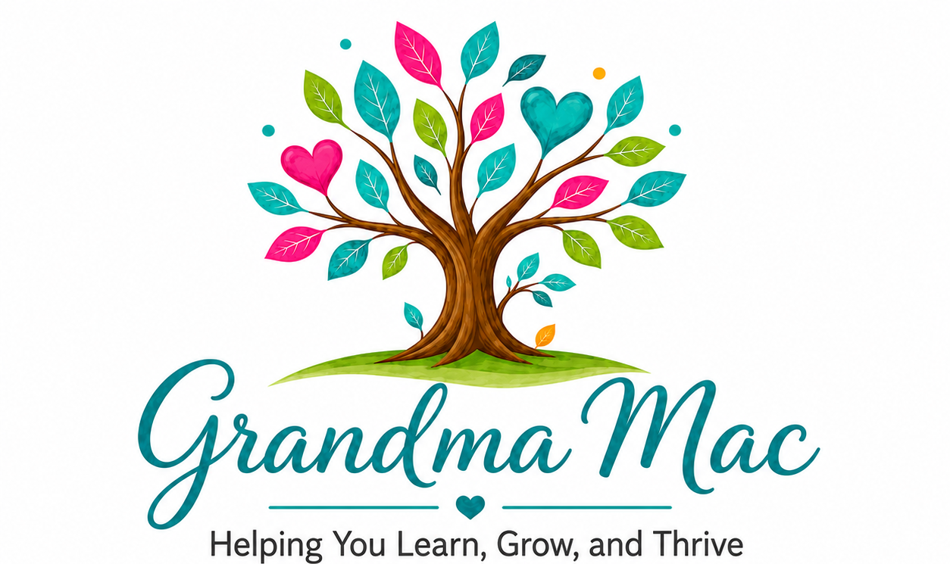

MUTUAL NON-DISCLOSURE AGREEMENT
Match Word Game Development Project

1. The Parties
This Mutual Non-Disclosure Agreement (the Agreement) is entered into as of the date signed below, between:

Disclosing / Receiving Party A: Ronna McKenzie, operating under the brand name Grandma Mac, Hope, British Columbia, Canada (hereinafter referred to as "Grandma Mac")

Disclosing / Receiving Party B: Gregory H., operating under Hampar Productions (hereinafter referred to as "Developer")

Both parties may share and receive confidential information in connection with the potential development of a mobile game application known as Match Word. Both parties agree to protect each other's confidential information under the terms of this Agreement.

2. What Is Confidential Information
For the purposes of this Agreement, Confidential Information means any information disclosed by either party to the other that is not publicly known, including but not limited to:

From Grandma Mac to Developer:
- The game concept, name, rules, and mechanics of Match Word
- The full Developer Technical Specification document
- The personal legal name of Ronna McKenzie — the Developer agrees not to disclose, reference, or associate the name Ronna McKenzie with the Grandma Mac brand in any public or private communication without express written permission
- Business strategy, pricing, revenue model, and subscription structure
- Information about other Grandma Mac products, apps, or projects
- Any login credentials, API keys, or technical access details shared during development
- Art direction, character designs, visual concepts, and branding materials

From Developer to Grandma Mac:
- Proprietary development methods, code frameworks, or technical processes
- Pricing structures, cost breakdowns, or business information
- Information about other clients or projects

3. Obligations of Both Parties
Each party agrees to:
- Keep all Confidential Information strictly private and secure
- Not disclose Confidential Information to any third party without prior written consent from the other party
- Use Confidential Information only for the purpose of evaluating or carrying out the Match Word development project
- Not copy, reproduce, or distribute Confidential Information beyond what is necessary for the project
- Notify the other party promptly if there is any unauthorized disclosure or breach

4. Portfolio and Public Reference Restrictions
The Developer agrees that:
- Match Word may not be listed, displayed, or referenced in the Developer's portfolio, website, social media, or any public-facing material without prior written permission from Grandma Mac
- The Developer may not use Match Word as a reference project when soliciting other clients without prior written permission from Grandma Mac
- The Developer may not disclose the identity of Grandma Mac or Ronna McKenzie as a client without prior written permission

5. Ownership of Intellectual Property
All concepts, designs, code, characters, game mechanics, artwork, and materials created specifically for the Match Word project are and shall remain the sole property of Grandma Mac (Ronna McKenzie). The Developer retains no ownership rights over any deliverables created under this project.
The Developer's pre-existing tools, frameworks, or code libraries remain the Developer's property, provided their use in this project is disclosed in advance.

6. Duration
This Agreement takes effect on the date signed and continues indefinitely. The confidentiality obligations survive the end of any working relationship between the parties and do not expire.

7. Exceptions
The obligations in this Agreement do not apply to information that:
- Was already publicly known at the time of disclosure through no fault of either party
- Is independently developed by the receiving party without use of the Confidential Information
- Is required to be disclosed by law or court order — in which case the disclosing party must be notified in advance where legally permitted

8. Remedies
Both parties acknowledge that a breach of this Agreement may cause irreparable harm that cannot be adequately compensated by monetary damages alone. In the event of a breach or threatened breach, the non-breaching party shall be entitled to seek injunctive relief and any other remedies available under applicable law, in addition to claiming damages.

9. Governing Law
This Agreement shall be governed by and interpreted in accordance with the laws of the Province of British Columbia, Canada, without regard to conflict of law principles.

10. Entire Agreement
This Agreement constitutes the entire agreement between the parties regarding confidentiality and supersedes any prior discussions or understandings on this subject. Any amendments must be made in writing and signed by both parties.

11. Signatures
By signing below, both parties agree to the terms of this Mutual Non-Disclosure Agreement.

Grandma Mac (Ronna McKenzie) — Signature: _______________________________________________
Printed Name: _______________________________________________
Date: _______________________________________________

Developer (Gregory H., Hampar Productions) — Signature: _______________________________________________
Printed Name: Greg Hamapr
Date: 2026.06.29

Please return a signed copy via the Freelancer platform chat only.
No email. No phone. Freelancer platform only.

